ENVI-CITY 

# College Name

* **SRM Institute of Science and Technology.**
* **Jadavpur University.**

## Faculty guide details

* NAME Dr E VIJAYARAGAVAN**.**
* EMAIL ID vijayare@srmist.edu.in
* DISCIPLINE Mechanical Engineering**.**
* YEAR Not applicable.
* MOBILE 9884214710.

## Team member details

## **TEAM MEMBER 1**

* NAME Pushpal Das.
* EMAIL ID pushpaldas2001@gmail.com.
* DISCIPLINE Electronics and Communication Engineering.
* YEAR 3rd year.
* MOBILE 8910497557.

## **TEAM MEMBER 2**

* NAME Abhishek Sarkar.
* EMAIL ID abhisrkr007@gmail.com**.**
* DISCIPLINE Electronics and Telecommunication Engineering.
* YEAR 3rd year.
* MOBILE 6290782054**.**

## **TEAM MEMBER 3**

* NAME Santhosh Kumar. R.
* EMAIL ID klt.santhosh2002@gmail.com.
* DISCIPLINE Electronics and Communication Engineering**.**
* YEAR 3rd year**.**
* MOBILE 9677867812.
* Presentation type- Pre-recorded talk
* We came to know about this program through our respected mentor

Dr E VIJAYRAGAVAN sir from SRM University.

ABSTRACT

The main objective of our research work is about time, people start to change their perspective on unbalanced economic development by viewing the world in a completely different way. What would help people achieve that is setting sustainable development goals?

So according to Wikipedia,

*“Sustainable development is the organizing principle for meeting human development goals while simultaneously sustaining the ability of natural systems to provide the natural resources and ecosystem services on which the economy and society depend. The desired result is a state of society where living conditions and resources are used to continue to meet human needs without undermining the integrity and stability of the natural system. Sustainable development can be defined as development that meets the needs of the present without compromising the ability of future generations to meet their own needs.”*

Understanding sustainable development and its goals is the first step to learning what we can do to make it happen. There are many initiatives already in place, but still many roadblocks to sustainable development that have to be overcome!

The main reason for us to do this research work is, to make sustainable development the norm, we have to change the vision of the cultures of each country. To change the vision of the culture two things, have to occur.

* The culture must value a global benefit more than a local one.
* A responsibility towards providing and sustaining resources for the future must be of more value than profit in the present must be developed.

Both of these are very hard to do because it requires an element of self-sacrifice to be adopted by the present society. The value of the future is something that is not held in high esteem when it comes to creating a profit, or to living with convenience.

The general self-focus of each generation is understandable, but as history has shown in other areas it can be expanded to include a sense of responsibility towards futures unknown that will allow for different choices to be made in the present.

Problems statement/challenges

* **Extinction of certain species specially birds due to the electromagnetic radiation and pollution.**

“There has been research done abroad which says there is some kind of impact on birds due to cell phone towers.”

The committee was constituted by the ministry of environment and forests to find out the impact of cell phones on birds, bees and wildlife in India.

Birds are dying due to **the electromagnetic radiation**. This radiation is created by wireless cell phones and high-tension electrical towers. There will be one day when we can't see a single bird in our beautiful planet.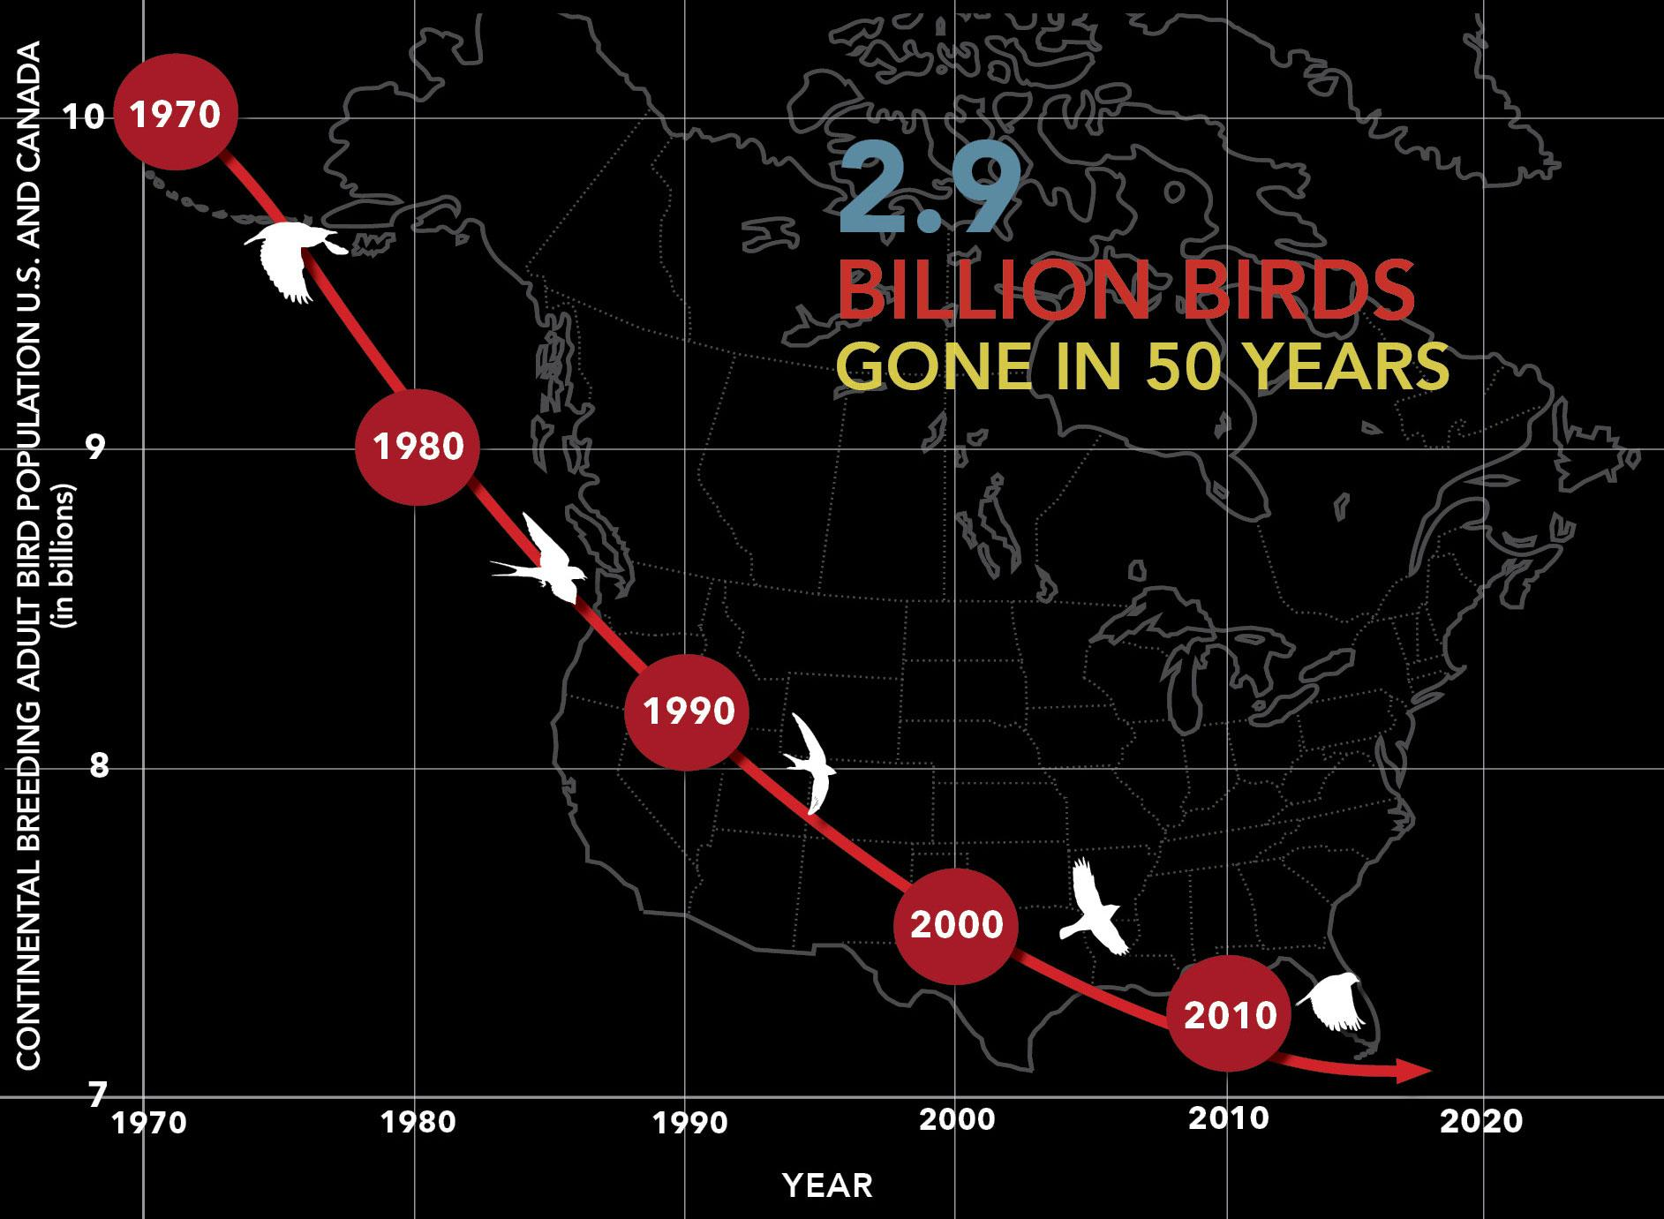

**Solution,**

Our team is trying to make a clear vision by not using any kind of cell phone towers, any LTE technology with 900-1800 MHz (2G network), 850Mhz (CDMA), 850-2500 MHz (4G LTE), which is enough to kill a beautiful species like a bird. Our team will make a change in this communication section, with the implementation of Wi-Fi networks (connected through the cables), in which our team can easily control the bandwidth of the Wi-Fi device, over which cellular calls can be done easily, creating an impact of changing the society by preserving the species of bird.

* **Overall losses between the power plant and consumers are then in the range between 8 and 15%.**

Technical losses are **normally 22.5%**, and directly depend on the network characteristics and the mode of operation. The major number of losses in a power system is in primary and secondary distribution lines. While transmission and sub-transmission lines account for only about 30% of the total losses. Therefore, the primary and secondary distribution systems must be properly planned to ensure within limits. The unexpected load increase was reflected in the increase of technical losses above the normal level Losses are inherent to the distribution of electricity and cannot be eliminated.

There are two types of technical losses.

**a. Permanent / Fixed Technical Losses.**

Fixed losses do not vary according to current. These losses take the form of heat and noise and occur as long as a transformer is energized. Between 1/4 and 1/3 of technical losses on distribution networks are fixed losses. Fixed losses on a network can be influenced in the ways set out below:

->Corona Losses  
-> Leakage Current Losses  
-> Dielectric Losses  
-> Open-circuit Losses  
-> Losses caused by continuous load of measuring elements  
-> Losses caused by continuous load of control elements

**b.Variable Technical Losses.**

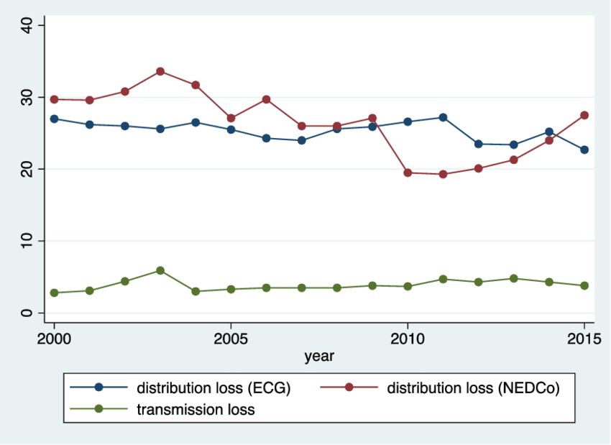

**Solution,**

Our team is trying to make an impact by stopping the electricity loss, that means zero transmission of electricity. Not only that our team is also focusing on no involvement of transformers, resulting in zero equipment's and maintenance free. And these all of the things can be achieved by what new our team is implementing with any kind of free energy in our environment present which includes solar energy, wind energy, energy created by the rotation of a turbine and many more. As a result of which we can beautifully implement our free sources of energy for the generation of electricity to the entire city and for many such purposes creating a healthy ecosystem around us.

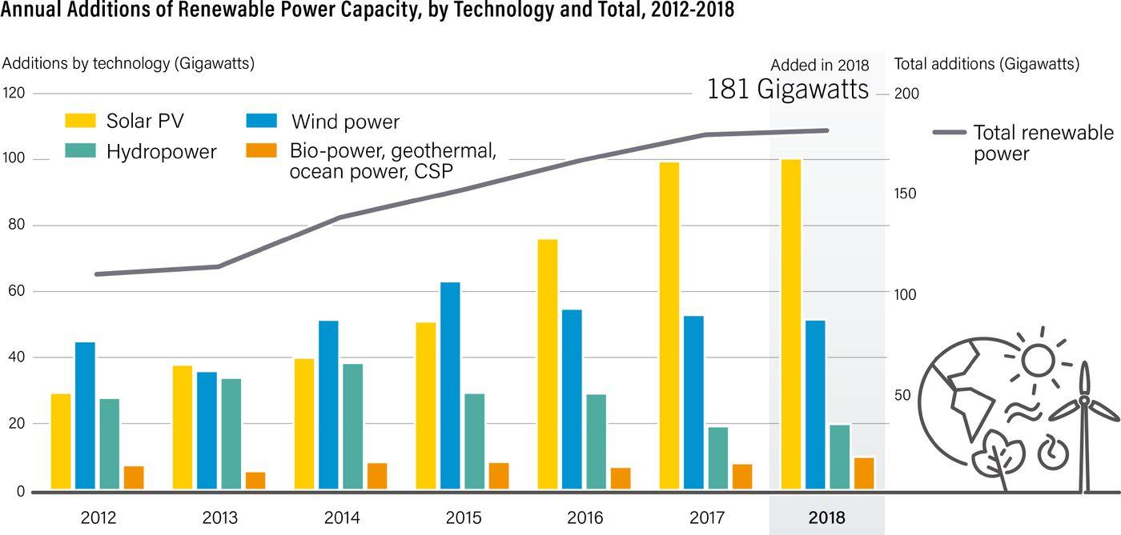

* **Air pollution, Waste management and recycling.**

The deleterious effects of ambient air pollution on human health have been consistently documented by many epidemiologic studies worldwide, and it has been calculated that globally at least seven million deaths are annually attributable to the effects of air pollution. In addition to the poor ambient air quality, there is increasing evidence that indoor air pollution also poses a serious threat to human health, especially in low-income countries that still use biomass fuels as an energy resource. Outdoor air pollution has become a cause for alarm in India in particular because recent data suggest that ambient pollution levels in Indian cities are some of the highest in the world.

Solid waste management is the one thing just about every city government provides for its residents. While service levels, environmental impacts and costs vary dramatically, solid waste management is arguably the most important municipal service and serves as a prerequisite for other municipal action. As the world hurtles toward its urban future, the amount of municipal solid waste (MSW), one of the most important by-products of an urban lifestyle, is growing even faster than the rate of urbanization.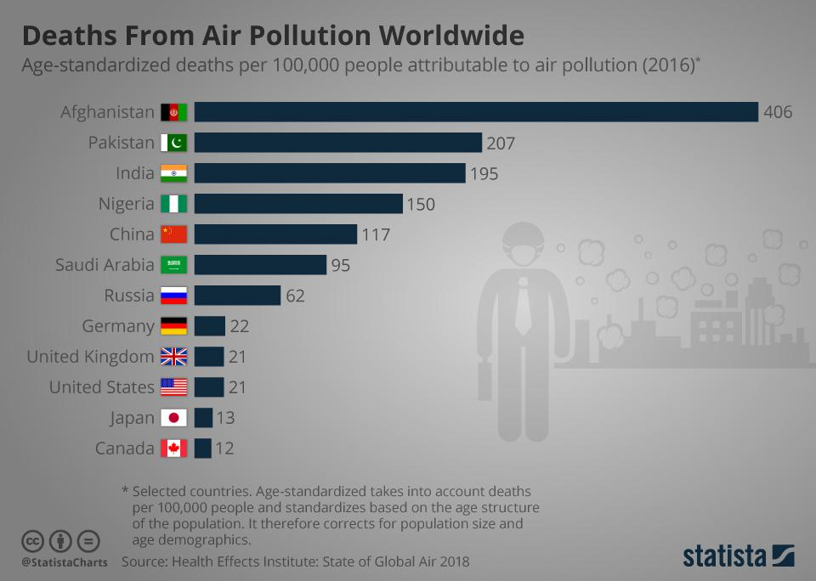

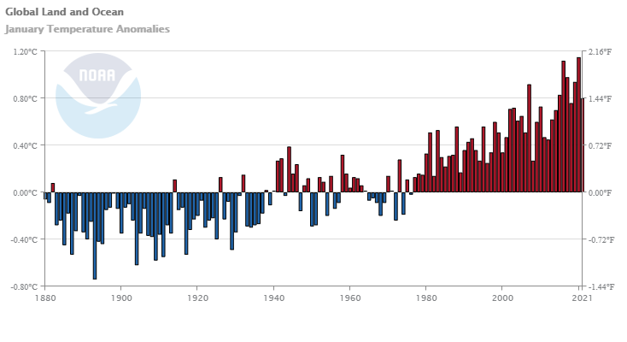

**Solution,**

Our team is will approach the solution by an automated air purifiers running by solar cells, which automatically purifies the air depending upon the concentration of the environment at that moment, therefore resulting in no air pollution, making it a healthy ecosystem. And also the source of energy for purifying the air is also a renewable source.

In waste management, our team will have a system completely based on Iot and the mode of automated transportation to make the waste management take place, after that the solution to this almost always includes either incineration or landfills or composting. But we cannot make compost out of inorganic materials which accounts for more than 60% of the total waste. So, we have to either incinerate the waste or store them in landfills with no planning for the future. Such methods will evidently saturate land area and with increasing human population, people will have lesser land to live on.

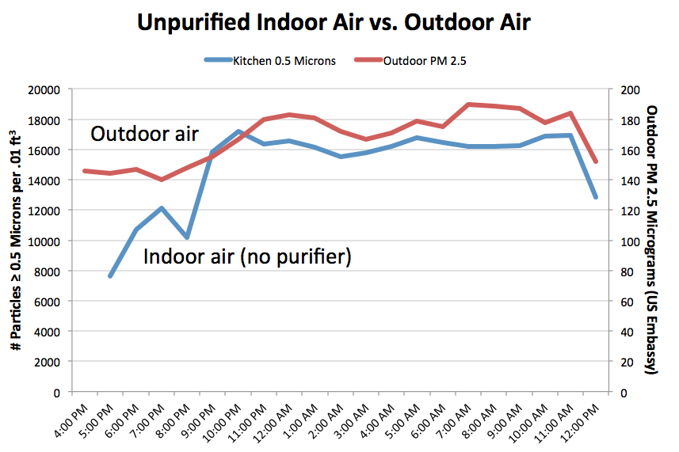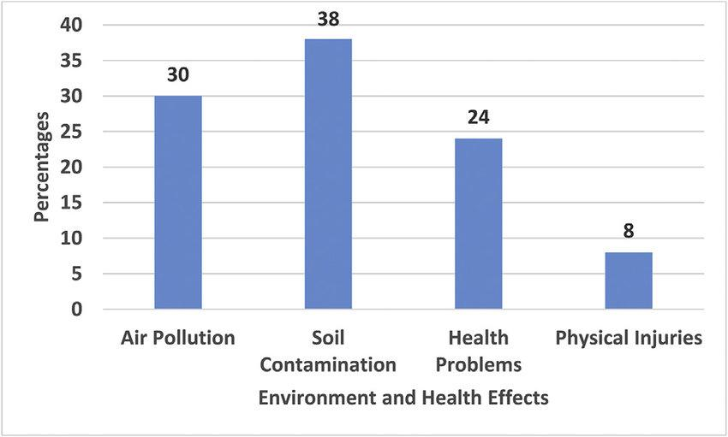

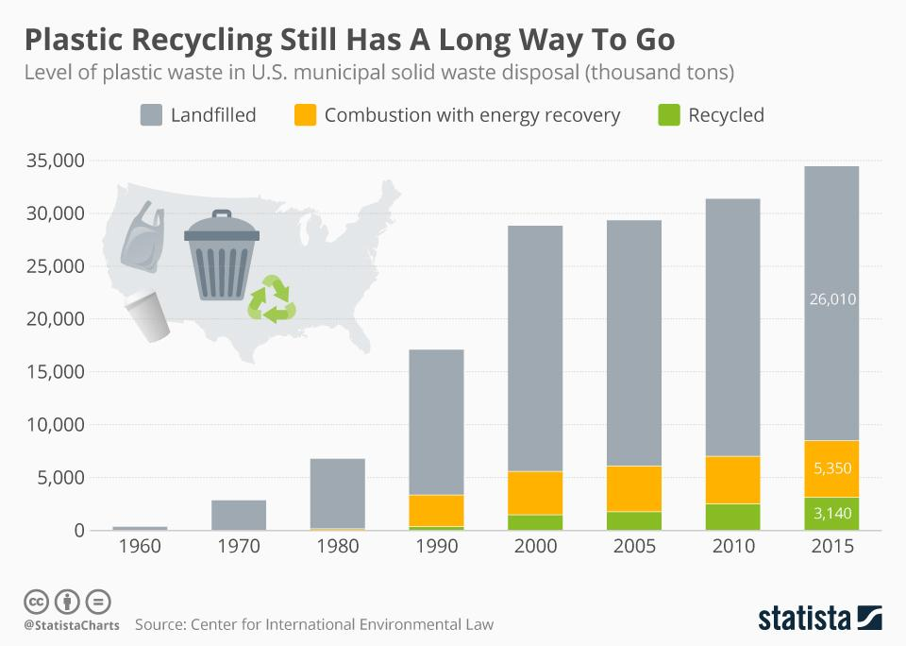

* **Smart harvesting (flood water), water logging in city pockets.**

Nowadays, various areas in the world have faced waterlogging and salinity problems, which are intensified by a myriad of factors including use of wastewaters for irrigation, unsuitable cropping pattern, torrential rains and floods, lack of sufficient drainage, uncontrolled drainage, lack of adequate knowledge, wrong management decisions and in general poor urban planning. Such waterlogging or flooding is harmful in cities where toxic drain water gets mixed. In farmlands, such flooding may be undesirable as some crops are destroyed in excess soil water.

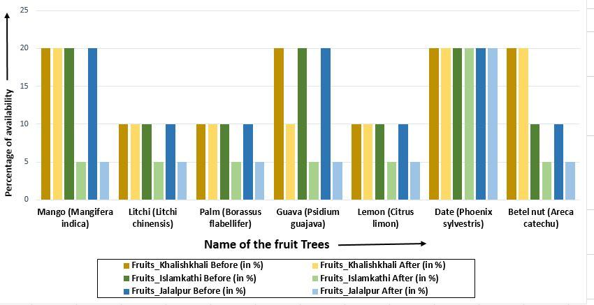

**Solution,**

Our team is trying to make an impact by planting some machine in such flood/waterlogging prone areas which will not only pump up the dirty water, but also filter and store it for household or agricultural purpose. Such a machine will automatically start working if a certain level of water on ground is reached. And the most interesting part here is, we can use this storage of water as an output to farming and agriculture, resulting in automation with respect to temperature, humidity and necessary things, creating a healthy eco system by not causing water logging and rather reusing for a better purpose.

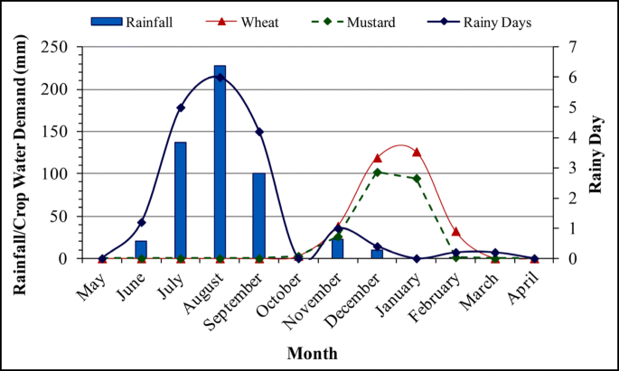

Conclusion

The biggest picture/ vision of this work is making a smart city with sustainable energy and in an eco-friendly manner. Implementing this project gives the change in eco-system positively. Because we are using getting electricity by the sustainable and renewable source of energy in which roof top solar cells were placed in every house and placing the vertical, turbines in the road side which is completely pollution-free and causes no greenhouse gases to be emitted after installation. And it reduced the dependency on foreign oil and fossil fuels. Not only that we can even have automated air purifiers running by solar cells, which automatically purifies the air depending upon the concentration of the environment at that moment .This smart city is made of with zero high band width signal waves for mobile and telecommunication instead we use shortrange Wi-Fi device's interconnected with wan cables which replaces the electromagnetic radiations and avoids the loss of a beautiful species like a bird from the environment and the as this is going to be Iot implemented city we will get most of the objects and devices interconnected each other, running on automation. Therefore, our team is having a simple idea of how we can use our renewable sources and gift it back again to the nature or environment making earth an eco-friendly and sustainable environment.

References

* <https://en.wikipedia.org/wiki/Sustainable_energy>
* <https://blog.se.com/energy-management-energy-efficiency/2013/03/25/how-big-are-power-line-losses/>
* <https://www.electricalindia.in/losses-in-distribution-transmission-lines/>
* <https://www.rediff.com/news/interview/will-cell-phone-radiation-kill-off-birds-like-shown-in-20/20181220.htm>
* <https://medcraveonline.com/IJAWB/the-electromagnetic-radiations-and-its-impacts-on-bird-diversity-in-india.html>
* <https://www.softeq.com/blog/how-smart-cities-are-leveraging-iot-for-waste-management>